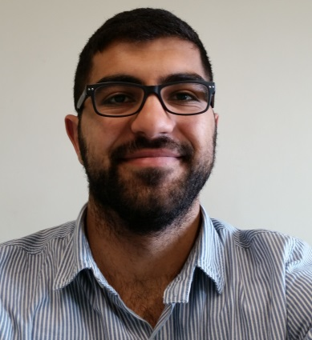

CENGİZ KARATAŞ
18.04.1993
cengiz.karatasoglu@gmail.com
Demirkapı Mahallesi . 1638 Sokak . No:20 D:4 Bağcılar / İstanbul
+90 546 240 39 65

Experiences:
May.2016 - Present Research Assistant
Yeditepe University Financial Economics

August.2018 – Present Math – Geometry Teacher on SAT, SAT Subject Math
Geomety Teacher on YÖS
Metropol Education Institues

Education:
09.2015-Present Yeditepe University, Financial Economics – Doctorate, GPA:3.57
09.2010-06.2015 Yeditepe University, Mathematics –GPA:3.6, (%100 Scholarship) (Graduates with High Honours Degree)
09.2006-06.2010 Bursa Celal Bayar Anatolian High School, GPA: 80

Languages: English: Advanced

Research and Projects :
1. Karatas Cengiz, Yilmaz, A., Unal, G., (2016). Wavelet based analysis of major real estate markets. Journal of Advanced Studies in Finance, (Volume VII, Winter), 2(14): 107-116. DOI:10.14505/jasf.v7.2(14).02.
2. Cengiz KARATAS, Gazanfer UNAL, and Adil YILMAZ . Co-movement and Forecasting Analysis of Major Real Estate Markets by Wavelet Coherence and Multiple Wavelet Coherence , Chinese Journal of Urban and Environmental Studies June 2017, Vol. 05, No.02 1750010
DOI: 10.1142/S2345748117500105

Technical Skills:
Microsoft Office(Word, Excel, Power Point), SPSS, E-views, Mathematica, Matlab, R

Personal Skills:
I consider myself as a goal-oriented person that value developing lifelong relationships, motivated and adaptable with high energy levels, able to play in the role of a team leader and team member.
Hobbies: Playing Basketball and running ( played basketball and running in the high school team)

Certificates :
actuarial science certificate Yeditepe University, Mathematics Department 06.2015

