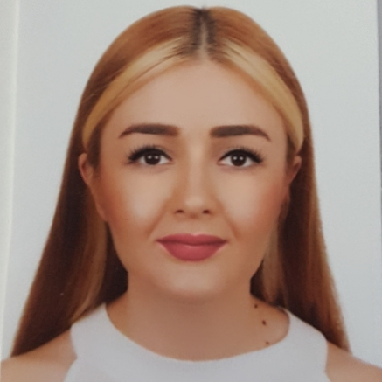
SİMGE ECEM ÇALIŞKAN
simgeecemm@gmail.com - simge.caliskan@yeditepe.edu.tr
0507 639 18 63
12.04.1993
EDUCATION
MASTER
YEDİTEPE UNIVERSITY
Institute of Social Science- Financial Economics (Full Scholarship)

UNIVERSITY 09.2011- 06.2016
YEDİTEPE UNIVERSITY
Faculty of Commercial Science- International Finance (English)) (%100 Council of Higher Education Scholarship)

-The Highest Ranked Student, Valedictorian

Faculty of Commercial Science- International Trade and Business (Double Major)

-The Second Highest Ranked Student

Faculty of Commercial Science

-The Second Highest Ranked Student of the Faculty

Grade Point Average of the Department of International Finance 3.75/4
Grade Point Average of the Department of International Trade and Business 3.84/4
HIGH SCHOOL 2007-2011
KIRKLARELİ ANATOLIAN HIGH SCHOOL 4,56 /5

WORK EXPERIENCE

T.C. YEDİTEPE ÜNİVERSİTESİ
ADVISORY BOARD MEMBER AT FINANCE DEPARTMENT 02.04.2018-
- Making regulations about the course schedule of the department.
- Trying to find solutions to problems that students are not satisfied.
- Working together with employees in sectors related to the department.

T.C. YEDİTEPE ÜNİVERSİTESİ
PROCTER OFFICE COORDINATOR 12.02.2018-
- Setting office hours for students who feel themselves inadequate in classes.

T.C. YEDİTEPE ÜNİVERSİTESİ
RESEARCH ASSISTANT 30.01.2017-
- Contributing to Academic Research
- Supporting Administrative Work
- Supporting Faculty Courses
- Attending and Supporting Conferences Organized by the Faculty.
- Supervising the Midterm and Final Weeks.

TÜRK DEMİRDÖKÜM FABRİKALARI A.Ş
TREASURY AND FINANCE INTERN 20.07.2015- 28.08.2015
- Editing Expense Forms
- Making Archive Control
- Sending Bills to the Dealers
- Daily Routine Works (e-mail, photocopy…etc.)

COCA COLA İÇECEK A.Ş.
FINANCE INTERN 16.06.2014 – 25.07.2014
- Entering Customer Orders into the System
- Editing Waybills and Invoices
- Follow-up Collections
- Follow-up Company Payments
- Sending Various Work-cycles

LANGUAGES
READING WRITING SPEAKING
ENGLISH upper-intermediate upper-intermediate upper-intermediate

RUSSIAN B1 A1 A1

COMPETENCIES

COMPUTER SKILLS
Microsoft Office Programs, EViews, Mathematica, SAP (FI,MM)

CERTIFICATES
- FXplus Financial Platform Training ( for Turkish Spot and Future Market Transactions, Use of Warrant Calculator, Technical Analysis Tools, Development of Indicators and Portfolio Management Techniques)
- Certificate of Attendance at Oxford- ISIS Summer School Foreign Language Course
- Certificate of Attendance at Guildford-ISIS Summer School Foreign Language Course
- Leadership and Administratorship- Ozan Demir (Ibs and Yumac)
- Foreign Trade- Bülent Balyemez (Ibs and Yumac)
- Marketing- Sibel Demirel (Ibs and Yumac)
- Career Life Coach (KYK)-Sevilay Demir (Erickson Coach.Int. & Transformal Breath)
- Career Days 2013,2014,2015,2016 (Yeditepe University)
- Rhetoric (Sagesse Consultancy)
- Stress Management (TMI)
- Sap Abap/4 Programming for Beginners- Şükrü İlker Bırakoğlu (Ibs and Yumac)
- Russian Language (Fifth Level)– The School of Foreign Language

REFERENCES

Prof. Dr. Veysel Ulusoy- Head of School of Applied Sciences at Yeditepe Üniversitesi
vulusoy@yeditepe.edu.tr 05325518897

Prof.Dr. Zeynep Aslı Alıcı- Head of the Department of International Finance&Deputy Dean
aalici@yeditepe.edu.tr 0532 276 14 63

Şenay Yalıç Çorbacı- Country HR Manager at Delphi Automotive Systems
0544 604 87 94

Adnan Kulhan-Industry Investment Manager at Alarko
(adnan.kulhan@alarko.com.tr) 0532 254 17 27

Bahattin Yaramış- Accounting Specialist at Coca Cola İçecek A.Ş.
(bahattin.yaramis@cci.com.tr) 0534 299 77 35

